Julien Collins
D614
Capstone Project

Seasonal and Inventory-Driven Multiple Linear Regression Analysis of Washington State Residential Real Estate Dataset

Research Question:
Is there a statistically significant relationship between seasonal market patterns and inventory conditions, measured by month of inventory, on days-on-market and sale-to-list price ratios across Washington State residential real estate?

The purpose of this study is to determine whether market timing and housing inventory conditions have a statistically significant relationship with residential real estate outcomes in Washington State. To further unpack this relationship, this analysis evaluates the magnitude of the relationship between seasonal listing periods and months of inventory, days on market, and sale-to-list price ratios. The relationship between these predictors and dependent variables exhibits the market conditions at play for home sellers, real estate professionals, and other real estate market participants. These variables specifically assess market competitiveness, pricing outcomes, and transaction speed, all of which affect the logistics of the sales strategy.
The justification for this research question stems from well-established industry practice and academic research, indicating that supply-and-demand dynamics are sensitive to the predictor variables, namely inventory conditions and seasonality. It is common practice in the real estate industry for professionals to base their listing strategy on perceived expectations of seasonal swings and inventory conditions; this approach is usually grounded in individual experience rather than concrete statistical findings (Crist, 2024). By quantitatively modeling the relationships among seasonality, inventory levels, and market outcomes using multiple linear regression, this study seeks to provide a data-driven framework for sellers, agents, and all real estate market participants. Unpacking the findings of this research question provides objective truths about generalized real estate outcomes across aggregated data for Washington State, equipping real estate professionals with enough evidence to make an informed decision on market-timing strategy.
The context of this research pertains to Washington State residential real estate market data. The data needed to answer the question is publicly available information from Redfin; the dataset includes 8,144 rows before removing any records (Redfin, 2025). This data includes aggregated county and metropolitan-level data on inventory, region, month of period, new listing count, days on market, and various other sold statistics:
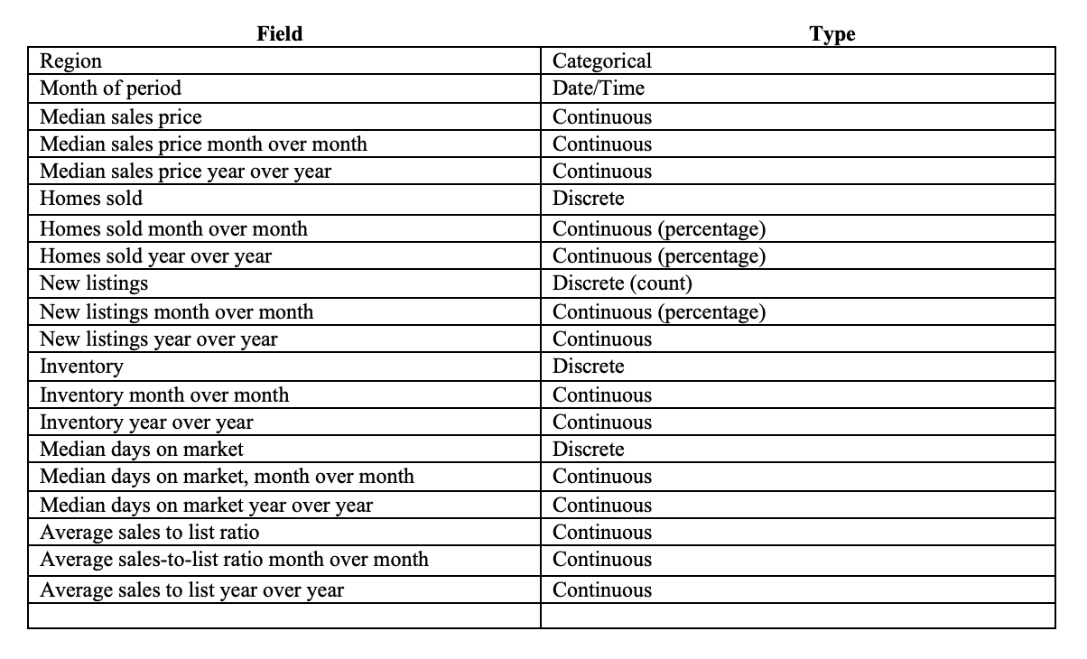

The data used in this source are publicly available residential real estate aggregations, consisting of monthly metrics at the county and metro levels in Washington State, gathered from the Redfin Data Center (Redfin, 2025). The use of aggregated data enables the discovery of long-term trends while preserving anonymity at the granular level.
This study evaluates two different hypotheses. The null hypothesis states that seasonality and housing inventory conditions do not have a statistically significant impact on days on market or sale-to-list price ratios. This would be shown through a linear regression model that fails to indicate any statistical relationship. The alternative hypothesis proposes that seasonal timing and inventory conditions have a statistically significant effect on these outcomes. An adjusted R-squared value of 0.10 or greater will be used as the threshold for supporting the alternative hypothesis and rejecting the null, as this benchmark is commonly used for macroeconomic data containing aggregated results and numerous external variables (Valchanov, I., 2023). Based on this prior research and observed behavior, it is expected that higher inventory levels will be associated with longer days on market and lower sale-to-list price ratios. In contrast, peak seasons will show the opposite outcomes. Along with the support of one hypothesis, the degree and magnitude of effect will also be empirically analyzed and discussed.
The data used in this analysis were obtained from the publicly available Redfin Data Center repository. This repository includes aggregated residential real estate metrics at the county and metro level for the United States. The specific dataset used for research includes monthly observations of the Washington State housing market spanning 2012–2025, with relevant fields such as region, month, homes sold, inventory, days on market, and average sale-to-list price ratios. Before cleaning, the dataset contained 8,144 rows of aggregated county- and metro-level data.
An advantage of gathering and using this aggregated data is its breadth and consistency. The aggregation of data at the county level reduces noise associated with individual property characteristics, focusing instead on broader market conditions that generally apply; it is also well-suited for identifying seasonal trends and competition dynamics. Further, public availability enhances reproducibility, allowing anyone to validate the results (NCEAS, 2022). Lastly, Redfin is widely recognized as one of the premier companies in the industry, known for its tech presence and data reliability (Redfin, 2025).
While gathering and analyzing aggregated data reveals broad trends within the real estate market dynamics, it fails to account for the granularity required to make property-specific claims. Property characteristics such as square footage, lot size, bedroom and bathroom count, among others, can provide helpful context in the explanatory power of real estate outcomes. For example, specific square footage counts could show different effects during specific seasonal periods; however, this aggregated data-gathering method could mask this micro, but relevant, finding. Although it would miss the granular level, it remains accurate and consistent with the research topic: to discover statewide market behavior rather than individual outcomes.
A few challenges were encountered during data collection. Initially, the raw data file contained all national data for every county, which was far too large for the research; only Washington State data was required. All that was needed, though, was a readjustment of the Tableau criteria. Next, there were formatting conventions errors in the dataset. These formatting errors were addressed during data preparation. Moreover, the unrestricted use of the data would need to be verified. It was determined that, so long as the data is cited, its use is permitted. Below is a picture of a portion of the raw, unformatted CSV.

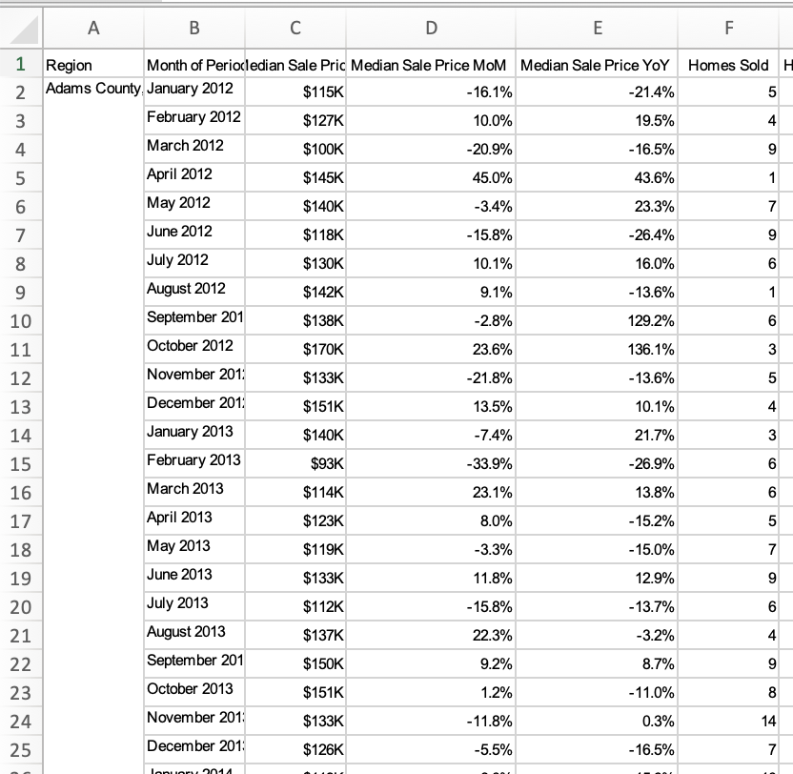

To extract and prepare the data, the dataset was first imported into the analysis environment using Python and the Pandas library within Visual Studio Code. This was performed using the read_excel() function, which allows tabular data to be imported into a DataFrame. Additionally, to confirm the dataset's shape and column structure, a print function was written. As expected, the dataset had 8,143 rows and 20 columns.
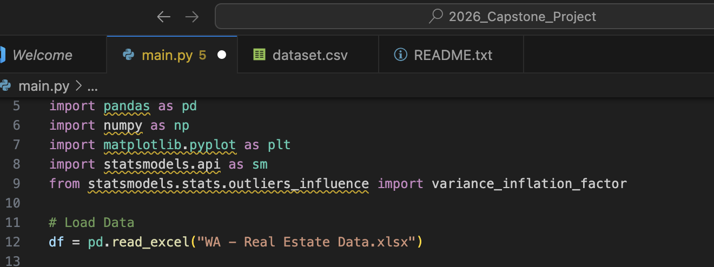

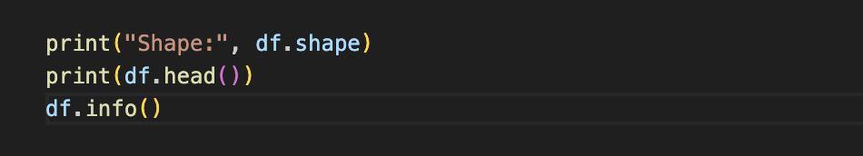

An advantage of using Python and the Pandas library for data extraction is the ability to import and validate dataset structures quickly. Validating a dataset structure ensures that errors in data types, missing values, and formatting are identified (Codesignal, n.d.). The accurate analysis of any dataset relies on the data integrity, which can and should be validated at the outset of a project. In this case, the data row count and shape are validated immediately after loading. A disadvantage to this method is that it cannot be done locally within Excel and instead requires additional environment setup. Essentially, there are more moving parts compared to performing the entire data extraction and preparation solely in Excel.
Once the data was extracted and imported, several preparation steps were performed to ensure analytical validity. First, the Redfin dataset's formatting conventions needed to be quickly addressed, as the spacing between the region identification and subsequent rows displayed “NaN” values. To validate that this was an issue, a missing_region_count variable was created to determine the number of rows missing a value. After creating print statements, it was confirmed that 8,093 region values were missing prior to being fixed. To address missing region values prior to analysis, a forward fill was applied to the region column in the DataFrame.

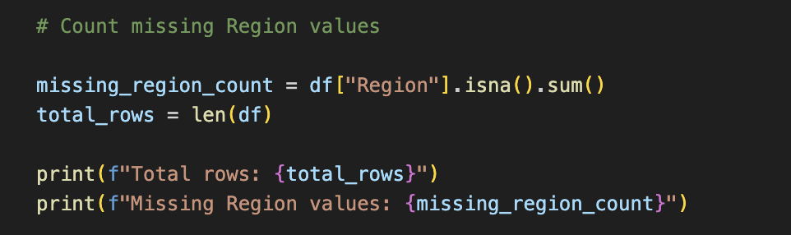

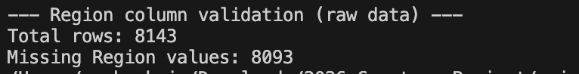

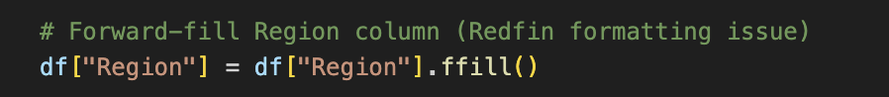

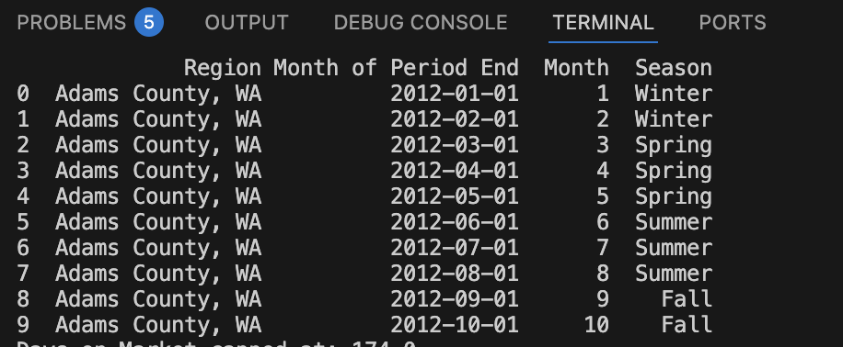

An advantage of taking the extra validation step before analysis is that it generally reduces errors and yields more accurate results (Codesignal, n.d.). Data validation using the Pandas library ensures data quality and integrity by handling missing values, duplicate entries, and outliers (Codesignal, n.d.). A disadvantage of this method is that the analyst could mistakenly remove key data or fields that are instrumental to deriving important insights.
Next, the “Month of Period End” column was converted to a datetime format to allow for time-series analysis. From this field, other time-based variables were created: year, month, and quarter. Adding these features helped create the seasonal groupings needed for the research and enabled time-series analysis. The categorical season variable was created by assigning three calendar months to each season: summer, winter, fall, and spring. This transformation made it simpler to perform descriptive statistics and linear regression modeling on the seasons.

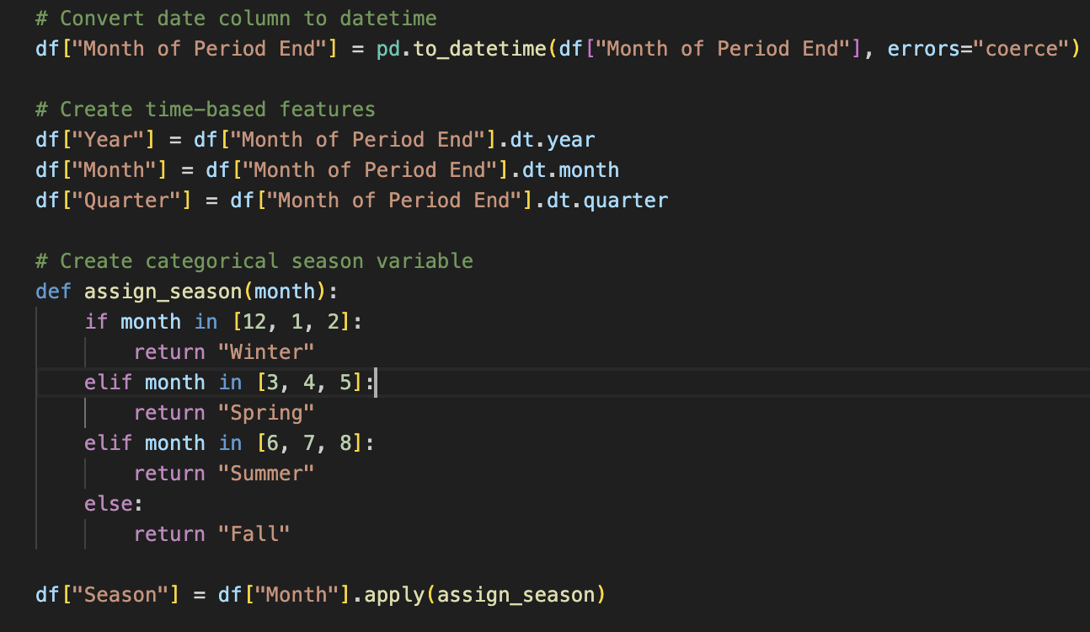

An advantage of this method is that it converts raw data into categories aligned with real estate market behavior. Industry research has shown that residential real estate markets exhibit predictable seasonal patterns that affect transaction volume, pricing behavior, and time on market (Crist, 2024). These seasonal effects suggest that timing plays a meaningful role in listing outcomes. The Federal housing market research further confirms the significance of seasonal patterns in prices, emphasizing that seasonality is essential for accurately interpreting trends (Doerner, W. M., & Lin, W., 2022). Suffice it to say, the creation of categorical variables mapped directly to seasonality proves to be efficacious in analyzing real estate data; thus, further validating its use in this research. While the seasonal variables include many relevant months, they do not perfectly capture the seasonal boundary, which varies from year to year. For example, in Washington, rain and snow can often persist into March, sometimes even April, mixing the meteorological conditions typical of one season with those of another; these varied occurrences can affect the rate at which homes are being shown, thereby rendering the boundary occasionally unreliable. In summation, a disadvantage is that calendar dates set seasonal boundaries and do not fully capture market dynamics.
Several numeric fields were also converted to numeric data types to ensure accurate results. Using these fields, the months-of-inventory variable was created. The variable is derived by dividing the housing inventory by the number of homes sold for each row. This metric is widely used in the real estate industry to indicate market supply and demand conditions (Doerner, W. M., & Lin, W., 2022). In the industry, higher months of inventory are typically associated with a lower sale-to-list price ratio. Creating this variable allows for that notion to be tested. An advantage of ensuring numeric type variables and then generating the “Months_Inventory” is that a critical macroeconomic variable can be derived to analyze the research question. The disadvantage of this method is that it excludes any “0” “Home Sold” values, which could be the accurate figure for a specific area (though it is unlikely).

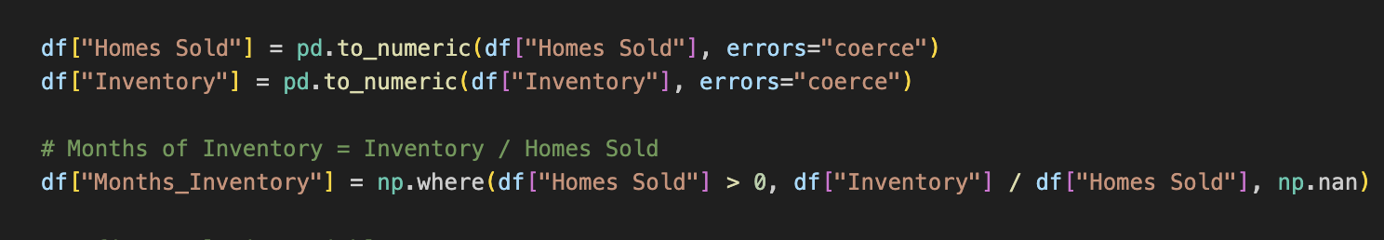

During the exploratory analysis, extreme values were found for days on market and months of inventory. To reduce the noise of these outliers, a 95th percentile capping was applied to both variables. Rather than removing observations, values exceeding the 95th percentile were capped at the threshold level. Capping extreme values ensured that the visuals produced afterward were more representative of the trend and that the regressions did not skew the distributions too heavily. An advantage of percentile-based capping is that it limits the influence of outliers on regression models, thereby reflecting typical market conditions. A disadvantage is that, while typical market conditions are assessed, extreme-value data that might provide insight into granular timeframes or seasons is omitted.
In summary, data extraction consisted of importing the Redfin dataset into Python with the Pandas library, using functions specific to that library. Data preparation involved cleaning, transforming, and generating variables pertinent to the research. Collectively, these steps enabled the refined analysis of the residential real estate dataset.
Multiple analytical techniques were applied to assess the research question. To evaluate the rudimentary statistics and details, descriptive statistics were used. Using Python-specific libraries, data visualizations were generated to support visual analytics of the research. A time-series analysis of the engineered variables was also conducted further to demonstrate the relationship between the independent and dependent variables. Lastly, a multiple linear regression model was constructed to determine whether a relationship exists between the variables and, if so, to what degree. These techniques were selected to quantify the relationship between seasonal market patterns, inventory conditions, and the dependent variables: days on market and sale-to-list price ratio.
The analysis began with exploratory and descriptive methods to understand the basic distributions of seasonal behavior in days-on-mark and sale-to-list price ratio. After completing the data preparation, summary statistics were produced to describe the analysis DataFrame.
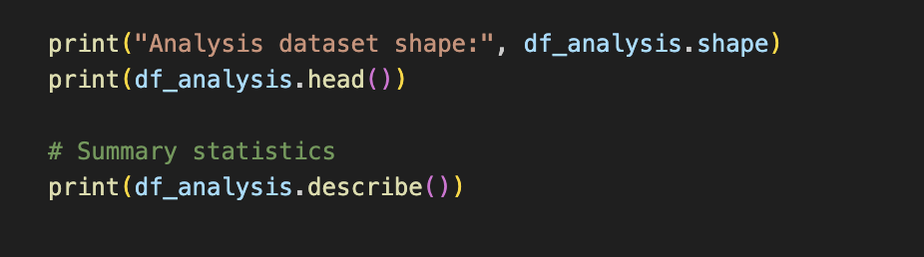
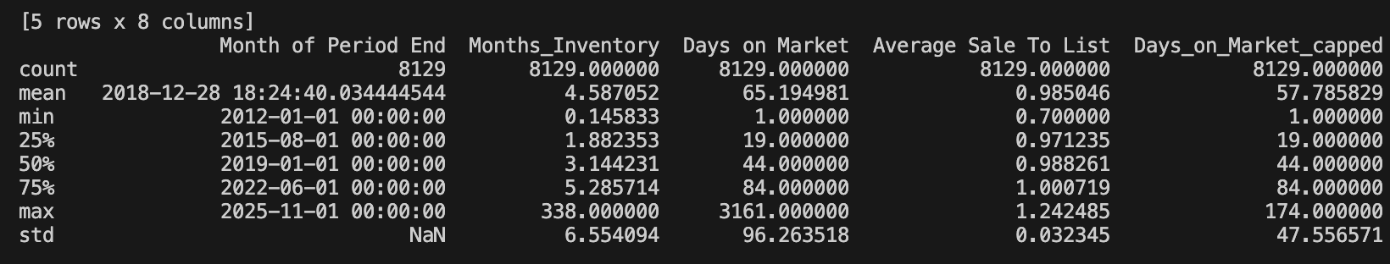
The summary statistics were generated to understand the typical values, spread, and extremes for analysis. Knowing the baseline conditions for the statistics provided the early context needed to proceed with the research. An advantage of the “.describe ()” function is that the overall baseline conditions can be understood prior to further analysis; it sets the tone for expectations within the research. For example, the sale-to-list price ratio has a gap of approximately 0.03 between the 25th and 75th percentiles. This shows that the spread is not very high, suggesting the ratio usually does not deviate much. A disadvantage of employing this technique early in the scripting process is that it may influence how the researcher conducts the rest of the study (DataHen, 2025).
To further understand the distributions of the variables, days on market (after being capped) were plotted on a histogram. Matplotlib, a Python visualization library, was used to carry out this task. In structuring the visualization script, the column “Days_on_Market_capped” from the “df_analysis” DataFrame was used. Relying on industry knowledge, the bins were arranged so that distributions were spaced every 10 days on the market. Additionally, the days-on-market were capped at 200 days. In the real estate industry, the average listing agreement is 180 days (Crist, 2024), providing a reason why the 5% cap would have omitted values well beyond that.

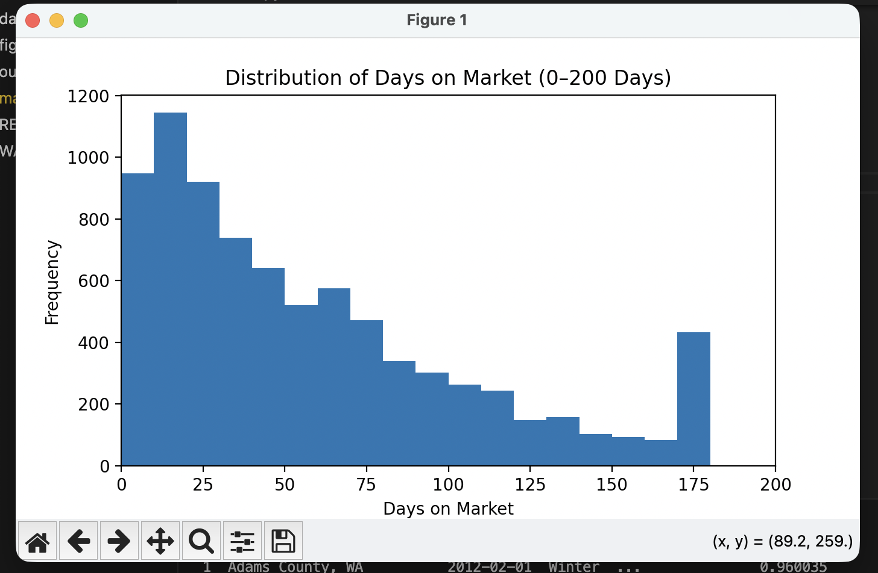
As shown in the figure, the 180-day mark has a higher bar than all values above 80 days, suggesting that a listing expiration becomes increasingly likely after that threshold. An advantage of plotting this is that it provides a holistic view of the data before breaking it down solely by seasonality and months of inventory. A disadvantage of pulling this prior is that it strays from the study's specific focus; however, understanding the entire picture is generally valuable to most market participants, warranting its inclusion.
Next, to obtain a broader, holistic understanding of the frequency distribution of sale-to-list price ratios, a histogram containing frequency on the y-axis and sale-to-list price ratio on the x-axis was developed. As demonstrated in the visual, the value spread for sale-to-list price is relatively low, which required extensive tinkering when scripting to ensure the bin count and visual representation looked adequate. A value of 1.00 or higher means the home sold for over its list price, whereas a value of 1.00 or lower means the home sold for under its list price. Looking at the visual distribution, it is abundantly clear that the values skew towards a ratio lower than the list price. It is also clear that there are more frequent observations of ratios below 1 than above it. An advantage of deploying this visual is that it clearly shows that, overall, homes tend to sell for less than their listed price.

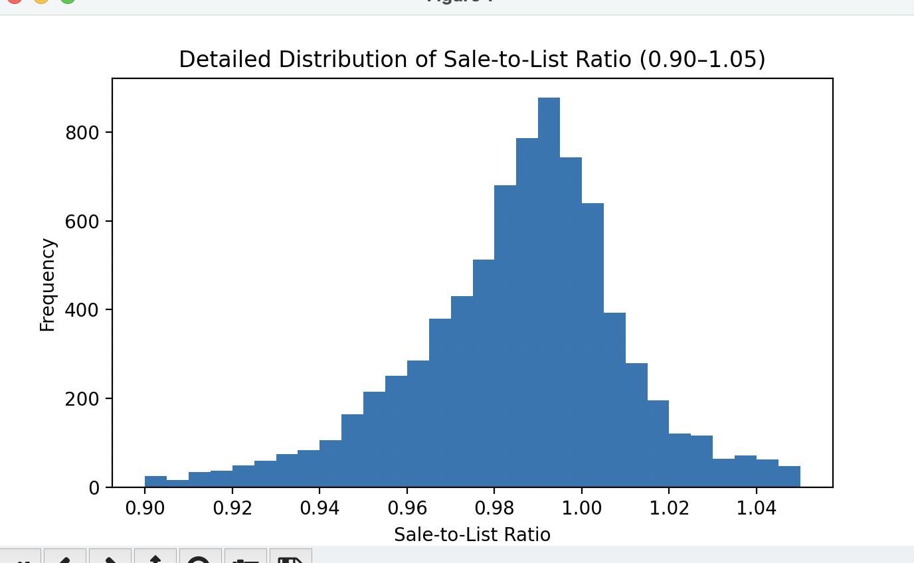

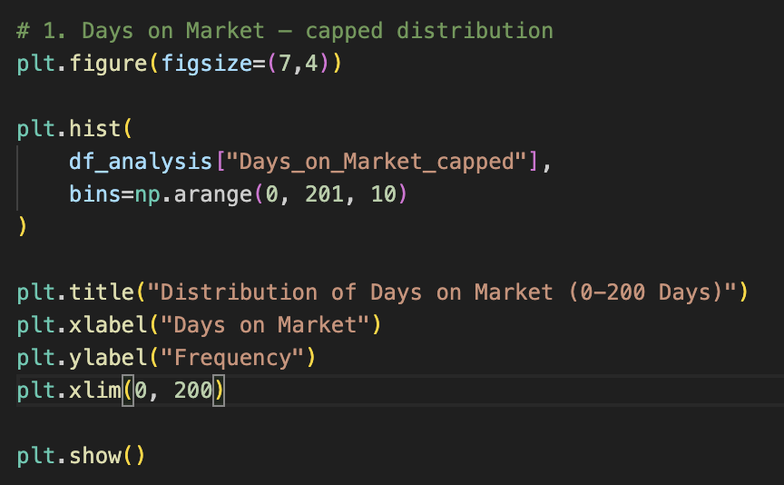
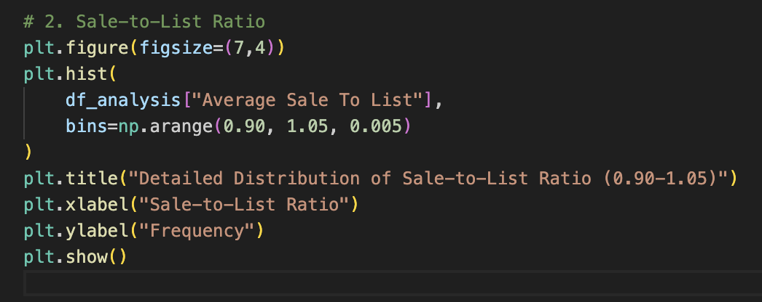

After mapping out the overall distributions, a box plot was generated to examine whether pricing outcomes differ by season. This was done by comparing the distribution of sale-to-list ratios across seasons on a boxplot. Therein, the median price ratio, season-to-season variability, and volatility in pricing ratios are shown. Albeit close, it clearly shows that the summer has a near-identical median while having less volatility in sale-to-list ratios. An advantage of using a boxplot is that it provides a visual aid for understanding the range of outcomes, as represented by the length of the rectangle, and displays the median price. However, given how slight the differences are, the boxplot shows little discrepancy.
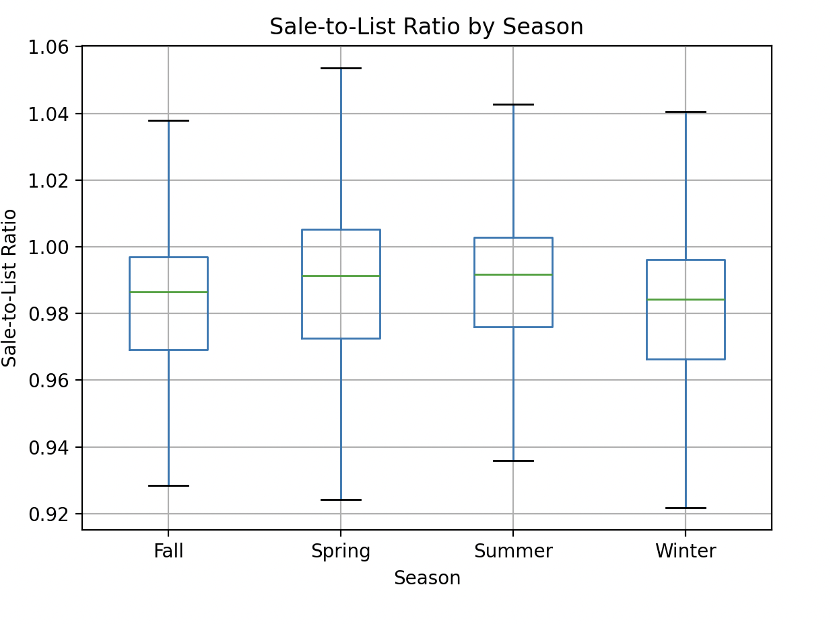

To further evaluate seasonal outcomes, a seasonal statistic summary was produced using the “Average Sale to List” and the “Days_on_Market_capped” columns. The means were produced under the variable “season_summary.” The seasonal summary of descriptive statistics shows that the average sale-to-list price ratio is very close, while the days on market show a greater range.

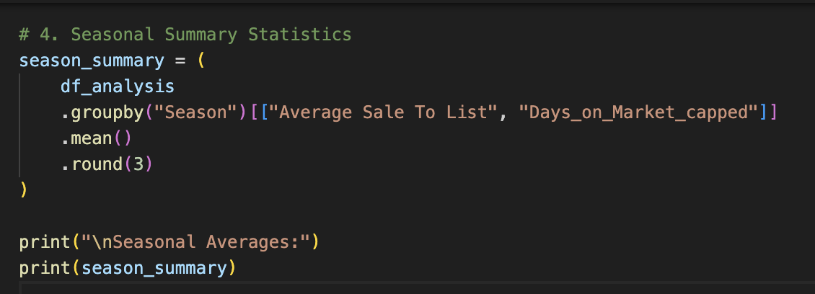
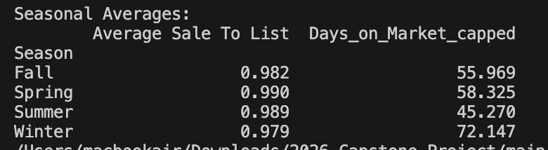

To strengthen the seasonal comparison beyond averages, a 95% confidence interval analysis was conducted for the mean days-on-market across seasons. Doing this quantifies the uncertainty of the seasonal mean and allows for a more precise comparison of whether seasonal differences are meaningful instead of due to varying samples (Amplitude, n.d.). The standard error was calculated and input as the standard deviation divided by the square root of the sample size (Amplitude, n.d.). The results were then visualized using an error bar plot to compare the seasonal means of days on market with uncertainty thresholds.

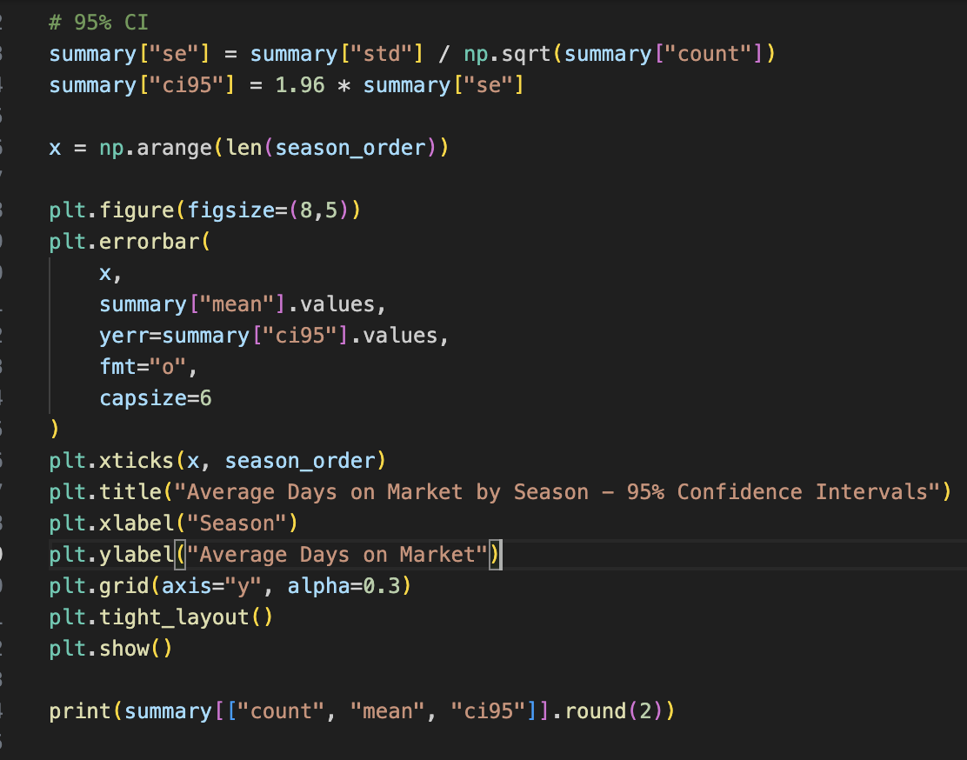

According to Cummings and Finch, an advantage of confidence intervals is that “plots of group means with 95% confidence intervals are a recommended method for visually comparing central tendency across categories…suggesting more substantial evidence of group differences (Jim Frost, n.d.). Further, the width of the confidence band indicates whether the estimate is stable or exhibits greater variability: the narrower the interval, the more it suggests stability. In contrast, the opposite is true as the interval widens. A disadvantage of this method is that the confidence intervals technically cap the distribution of days on market that may exist. For example, during seasons of greater variability, when homes might sit on the market for over 180 days, that variability may be muted within the result. In summary, this method provides a visual representation of uncertainty across seasons.
As shown, the fall and summer have narrower bands and lower days on market than the winter and spring. This suggests that homes sell slowest during the winter and fastest in the summer. The separation of intervals provides visual evidence of meaningful differences among the seasons.

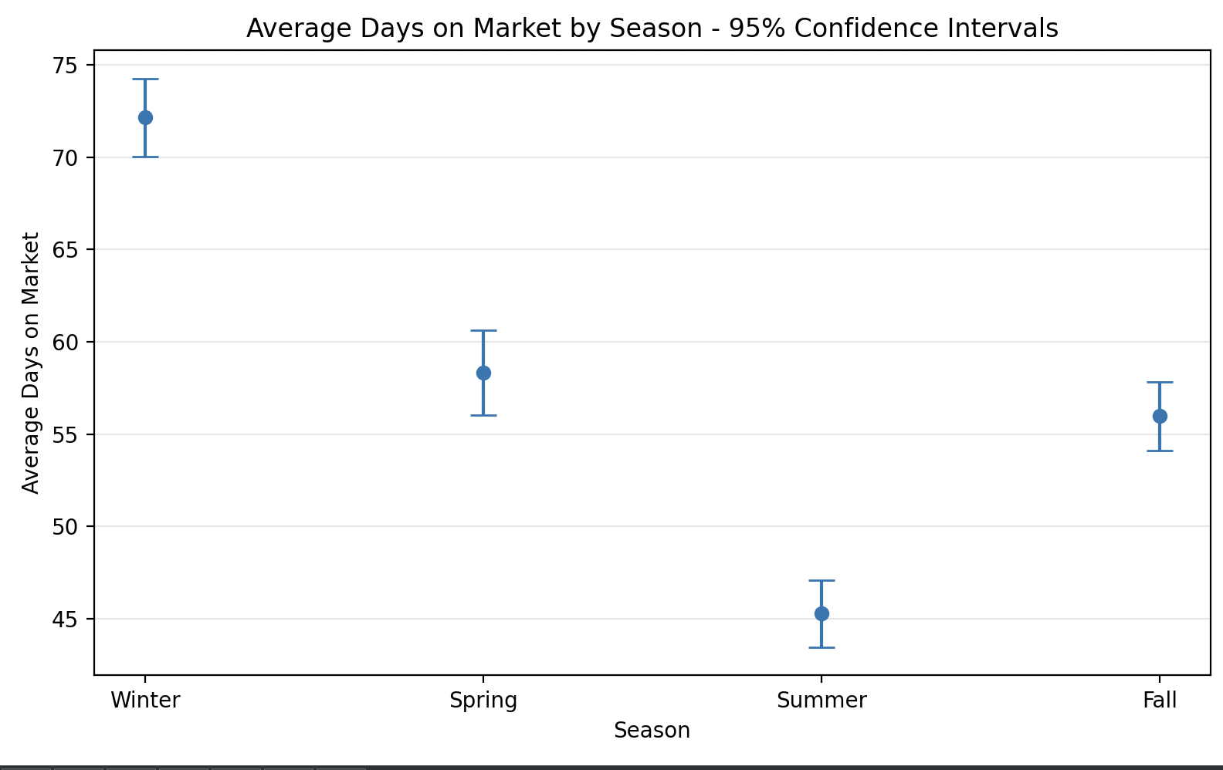

To evaluate the side-by-side distributions of seasonal days on the market, a loop was written to subset the data by season and plot a histogram for each season. The dashed line marks the seasonal median, which varies from season to season. As shown, the frequency of lower-valued days on the market in summer is far greater than in any other season, which is consistent with the visual showing the confidence intervals. The winter appears to have a more even distribution across days-on-market bins, suggesting that homes sold in the winter tend to have more extended list-to-sell periods. The same logic and scripting were applied to the list-to-price ratio panels, too; however, the bins differ to accommodate the measurement scale.

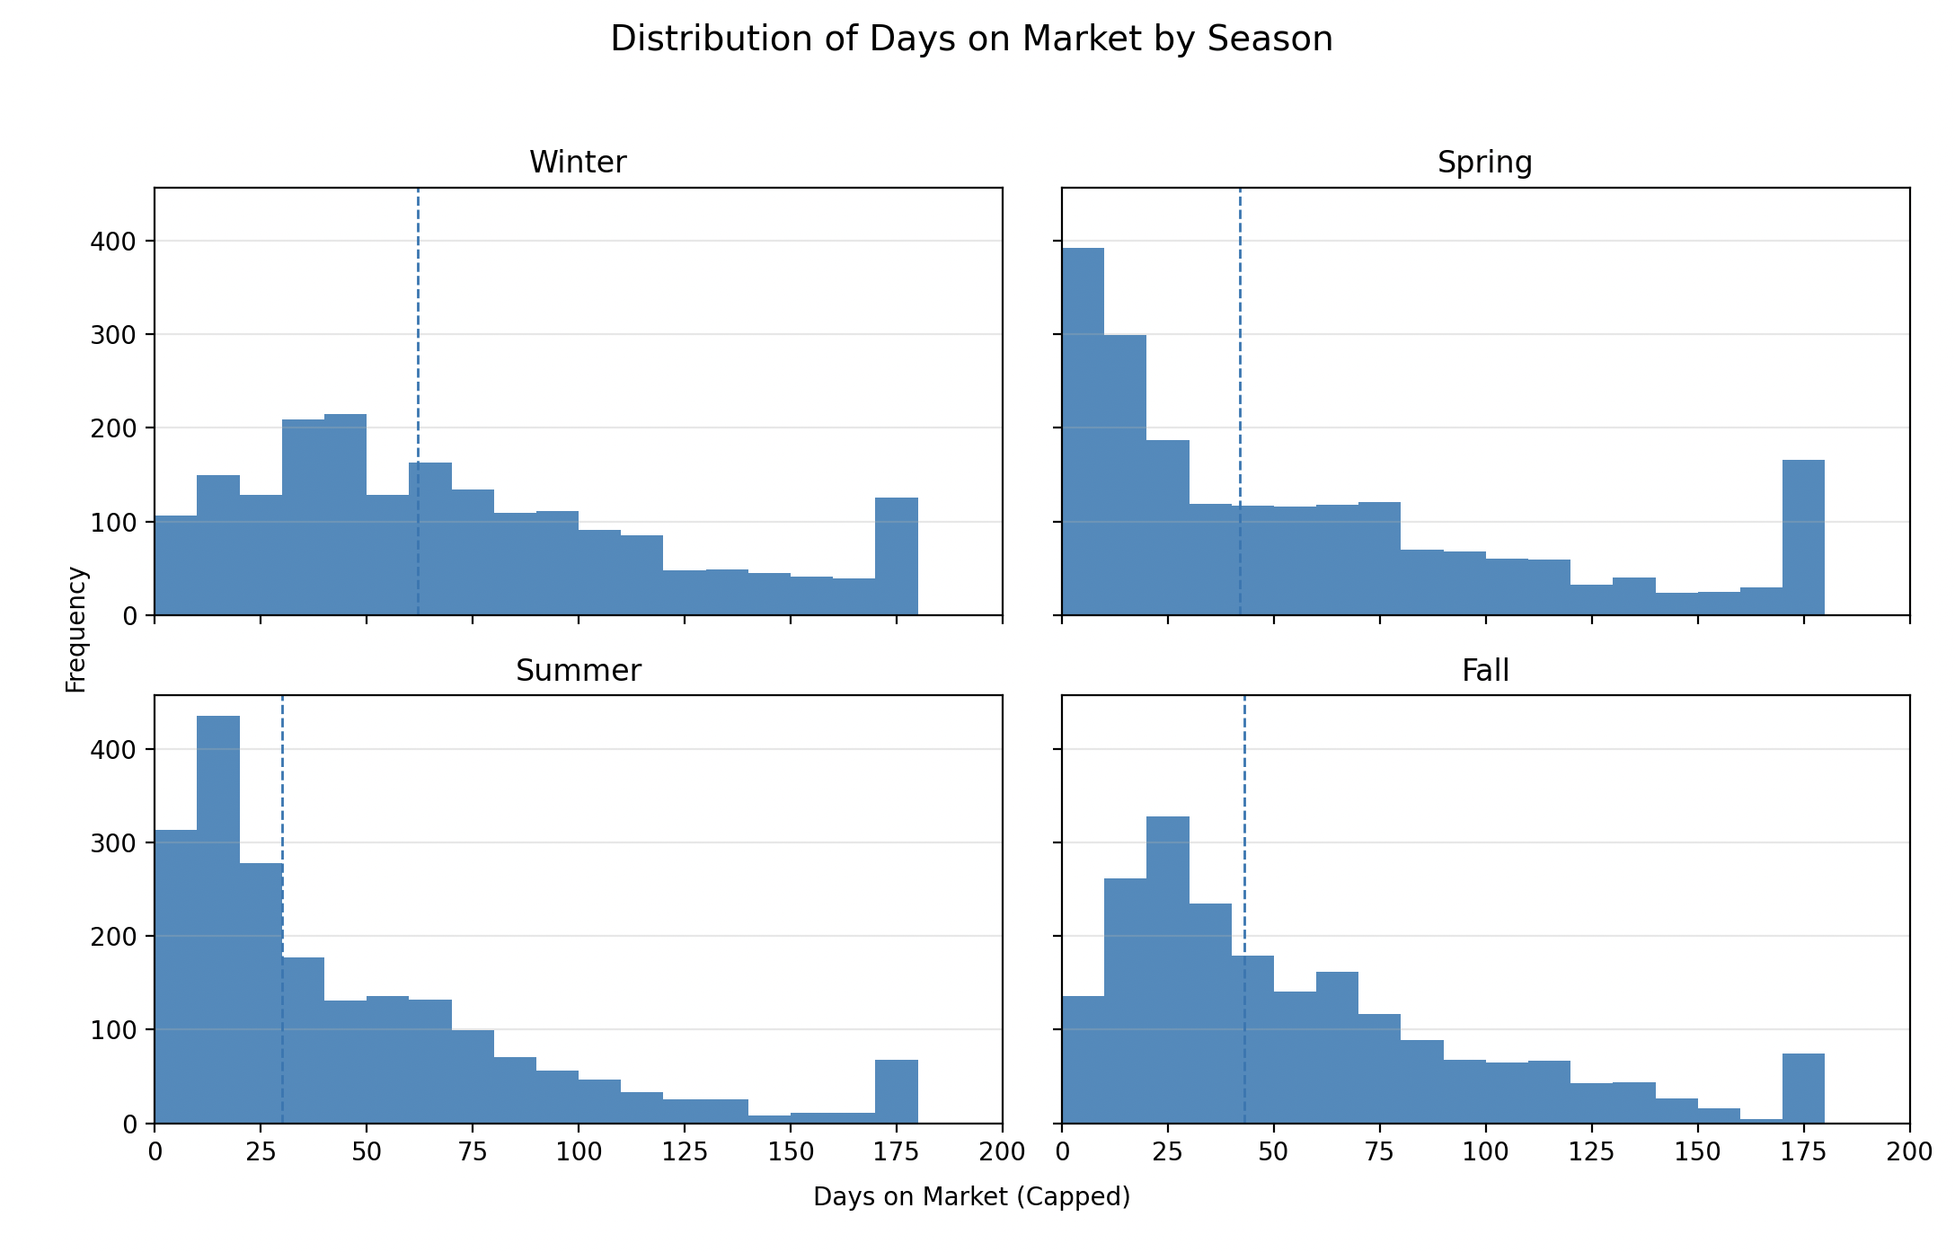

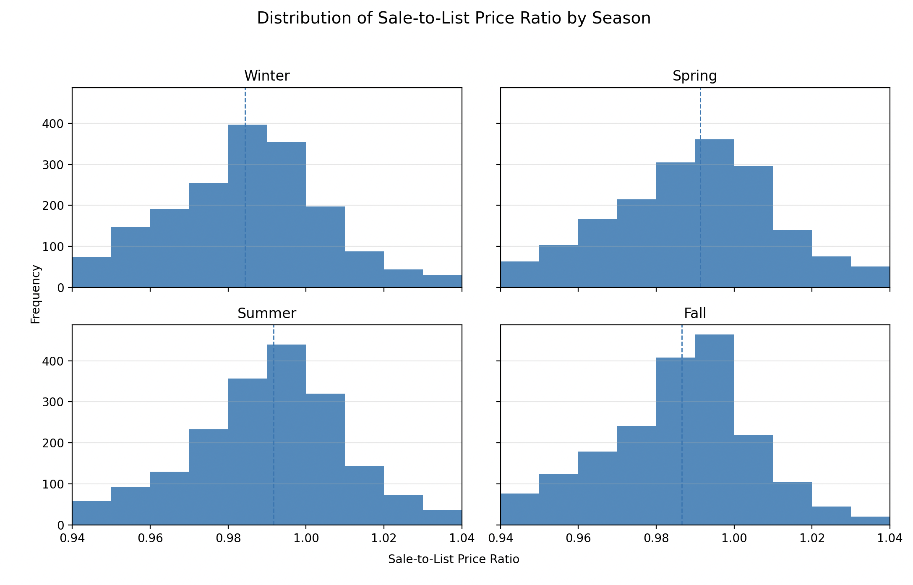

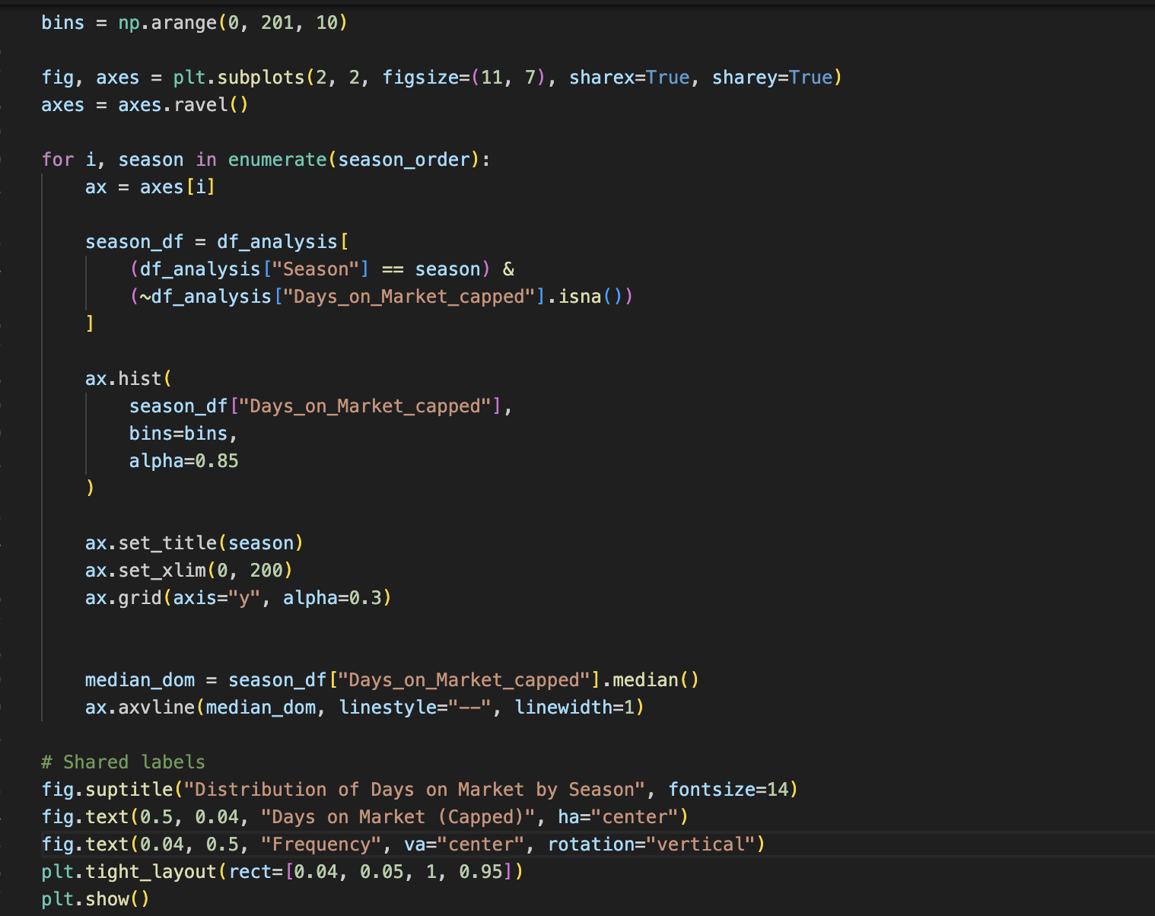
As mentioned before, the logic and scripting remain consistent for the sale-to-list price ratio as well. This bin arrangement of 0.94 to 1.041 adequately represents the frequency distribution by stepping up by 0.01 (or 1%) for each bin within that range. Given the narrow spread of outcomes, every percentage point is significant; this is especially true when considering that average sold values can exceed $1 million in certain Washington metropolitan areas. Thus, understanding this frequency dynamic within seasonal periods arms real estate market participants with pertinent information. An advantage of a 2 x 2 histogram layout is that it allows direct comparison of complete distributions across seasons. The summary statistics can capture this numerically; however, by scaling and setting axis limits, these visual displays show the differences in central tendency, skewness, and dispersion between the seasons. A disadvantage of the histogram is that it is only descriptive and does not quantify the statistical significance. The histogram panels are also relatively small for the document layout.
To formally evaluate whether seasonal market patterns and inventory conditions are statistically significantly related to real estate outcomes, multiple linear regression was selected. In academic literature on real estate markets, multiple linear regression has proven to be a practical and insightful modeling method for capturing market trends, temporal effects (such as seasonality and weather), and pricing power (Shukla, S., 2024). Linear regression approaches have been often used to identify statistically significant relationships between market behavior and pricing. This method of analysis can provide meaningful insights into real estate market performance. This approach is appropriate for real estate market analysis, especially given the plethora of macroeconomic factors that often influence the dynamic. Regression analysis provides a quantitative framework for testing the study’s hypothesis by providing an understanding of the magnitude and statistical significance of the relationships between the independent variables and the dependent variables (GeeksforGeeks, n.d.).
Two ordinary least squares (OLS) regression models were utilized to examine the research question and focus on a specific outcome: days on market and the sale-to-list price ratio. The former represents the speed at which transactions occur, while the latter represents the price's performance. The independent variables for the models include months of inventory and seasonal indicators. Months of inventory is used as a continuous measure of market supply, suggesting the supply constraints or abundance affecting competition. Winter was selected as the baseline season for the reference category. With this, the seasonal coefficients can be interpreted as deviations from winter market conditions, which is a standard industry practice (Shukla, S., 2024). The linear regression models were implemented using the statsmodels library in Python, which provides statistical outputs that allow for academic analysis (Langford, R., 2017). Prior to modeling, the season variable was converted to categorical dummy variables using one-hot encoding, therefore omitting the winter category to avoid multicollinearity (which is ideal when performing linear regression). Additionally, an intercept was added to each model to supplement the baseline. The two dependent variables, “Days_on_Market_capped” and “Average Sale To List", were analyzed separately.
Multiple linear regression was selected because it aligns with the research objective of understanding and quantifying relationships between market timing, the inventory conditions, and real estate outcomes. It produces reproducible, verifiable results that offer insights into the magnitude of effect that these variables have on real estate outcomes (Real Python, 2025). Further, it produces statistical significance measurements that otherwise would not be described through descriptive statistical modeling. One advantage of performing regression analysis is that it allows the influence of seasonality and inventory conditions to be independently evaluated (DataCamp, n.d.). These variables can concurrently drive outcomes; without regression modeling, their effects may confound with one another and obscure the result. confound the results and render insightful analysis obsolete. A disadvantage is that it assumes linear relationships, oversimplifying the model and failing to account for extraneous variables that influence the results.
To begin, I put in another check to drop missing values and select the variables for the model. This block creates a dataset by selecting only the columns needed for the model. After dropping rows with missing values, a copy of the resulting dataset is produced. This is a subset of the main DataFrame.
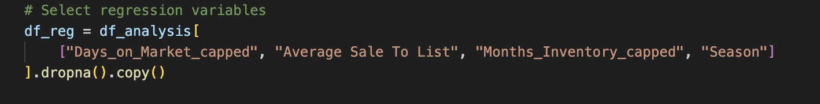
The season order is then defined, and the seasonal variable is encoded as categorical using Pandas. This categorical encoding prevents accidental reordering of categories and makes the baseline the winter. This specific order ensures those categorical predictors are treated consistently. This makes it reproducible because the same season categories are always the same.
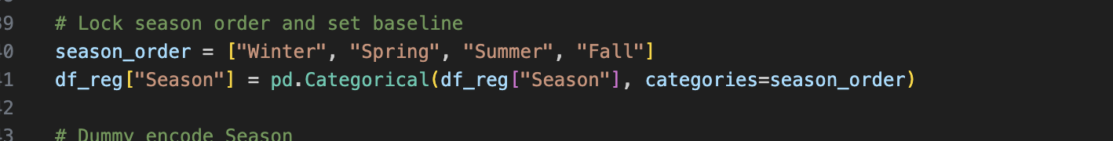
Next, the seasons are dummy-encoded, with winter as the baseline. This block transforms the categorical season variable into a binary variable. The drop_first=True line ensures that the first column, winter, which serves as the baseline, is omitted, leaving you with three dummy columns. Each observation is represented by 1 if the season matches or 0 if it does not; if no match is found within the three columns, it implies a Winter match. The justification for this approach is that it produces numerical output from categorical values, which are required for OLS regression. This now allows the model to estimate mean differences among the categorical variables contained within the seasons.
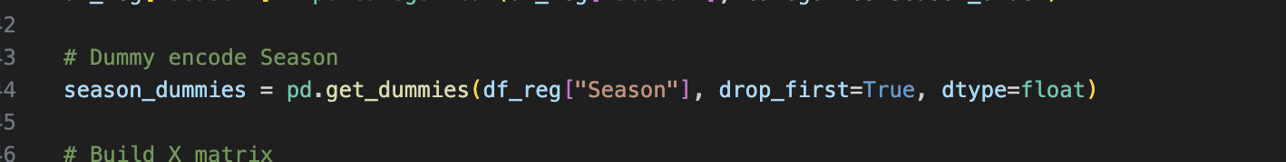
After that, the design matrix is built, which includes inventory and seasonal dummies. The blocks produces the predictor matrix by combining the “Months_inventory_capped” and the seasonal dummy predictors. This step defines multiple linear regression and tests the two variables and the effect at once: inventory conditions and seasonality. The coefficient on months of inventory represents the expected change in the outcome for a one-unit increase in inventory, holding the inventory holding season constant; seasonal coefficients are the expected difference in the outcome between spring/summer/fall and winter, holding inventory constant. An intercept is also added to represent the model’s baseline expected outcome, providing a foundational value to the model.
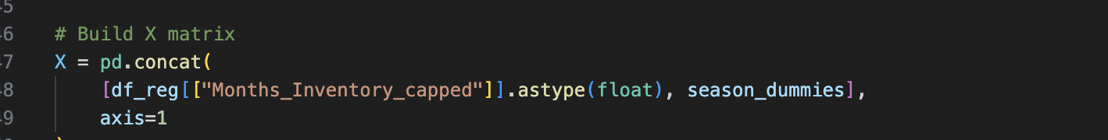
Given that the research question has two dependent variables, capturing their outcomes is critical. To represent the capped days on market in the regression model, y_dom serves as that outcome vector, and y_stl is the sale-to-list ratio. The outcomes have different scales and distributions, so estimating separate models is clearer than combining them.
For the first model, OLS regression for days on market is performed using the predictor matrix “X.” The “.fit()” function estimates coefficients, adjusts R-squared, and provides other diagnostics for the model. The justification for implementing this is that it addresses whether inventory conditions and seasonal timing have a statistically significant relationship with the time a home sells. The model quantifies the expected difference in days-on-market associated with inventory and seasonality by estimating the inventory and seasonal coefficients.
Model 2 fits a OLS regression with the same predictor variables but a different dependent variable, that being the sale-to-list price ratio. This model is responsible for estimating whether higher inventory and seasonality equate to statistically meaningful differences in pricing performance. A ratio that is above 1.0 usually suggests stronger demand, whereas a lower ratio indicates a weaker demand.

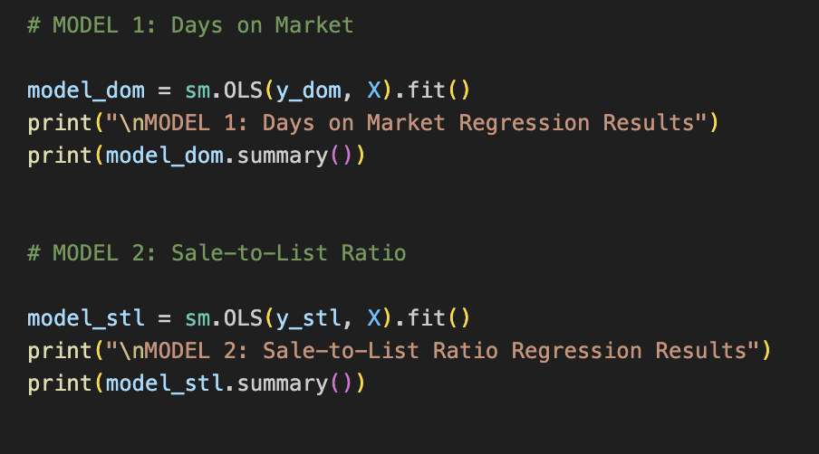

The first regression model demonstrates strong explanatory power, with an adjusted R-squared value of 0.526; this suggests that about 52.6% of the variation in days on market is accounted for by the inventory conditions and seasonal timing. This adjusted R-squared value far exceeds the threshold of 0.10 in the alternative hypothesis, which supports evidence against the null hypothesis. The coefficient for months of inventory is positive and statistically significant, with each additional month of inventory is associated with an increase of approximately 10.8 days on market (p-value < 0.001). This supports the agreed-upon idea that higher inventory levels reflect weaker demand relative to supply, resulting in longer days on market (Crist, 2024). It was found that, with a p < 0.001, Spring listings sell about 8.5 days faster than Winter listings; Summer listings sell about 20.3 days faster, having the most substantial seasonal effect; Fall listings sell approximately 10.5 days faster than Winter listings. These results confirm that winter is the slowest season for real estate sales, while summer is the fastest. The size of these coefficients suggests that seasonality plays a meaningful role in market timing and how fast a home may sell.
The second model evaluates the effect of the same independent variables on the sale-to-list price ratio. This model produced an adjusted R-squared value of 0.355, suggesting that inventory conditions and seasonality explain 35.5% of the variation in the sale-to-list price ratios. As previously mentioned, the adjusted R-squared threshold is 0.10; therefore, this value is well above the threshold and provides evidence to reject the null hypothesis. Further, the coefficient for months of inventory is negative and statistically significant: -0.0061 (p < 0.0001). This suggests that for every additional month of inventory, the sale-to-list price ratio should decrease by an average of 0.61%. This supports the idea that higher inventory conditions weaken seller pricing outcomes. Summer and spring listings show a statistically significant increase in sale-to-list price, with positive coefficients of 0.0059 for the former and 0.0075 for the latter (about 0.6% and 0.75%). Maintaining inventory conditions constant, homes listed during these seasons sell for about 0.6% or 0.75% closer to or above list price than winter listings (which serve as the baseline). Fall, however, clocked in with a p-value of 0.725, suggesting that there is no statistically significant difference in the sale-to-list price ratio between fall and winter.

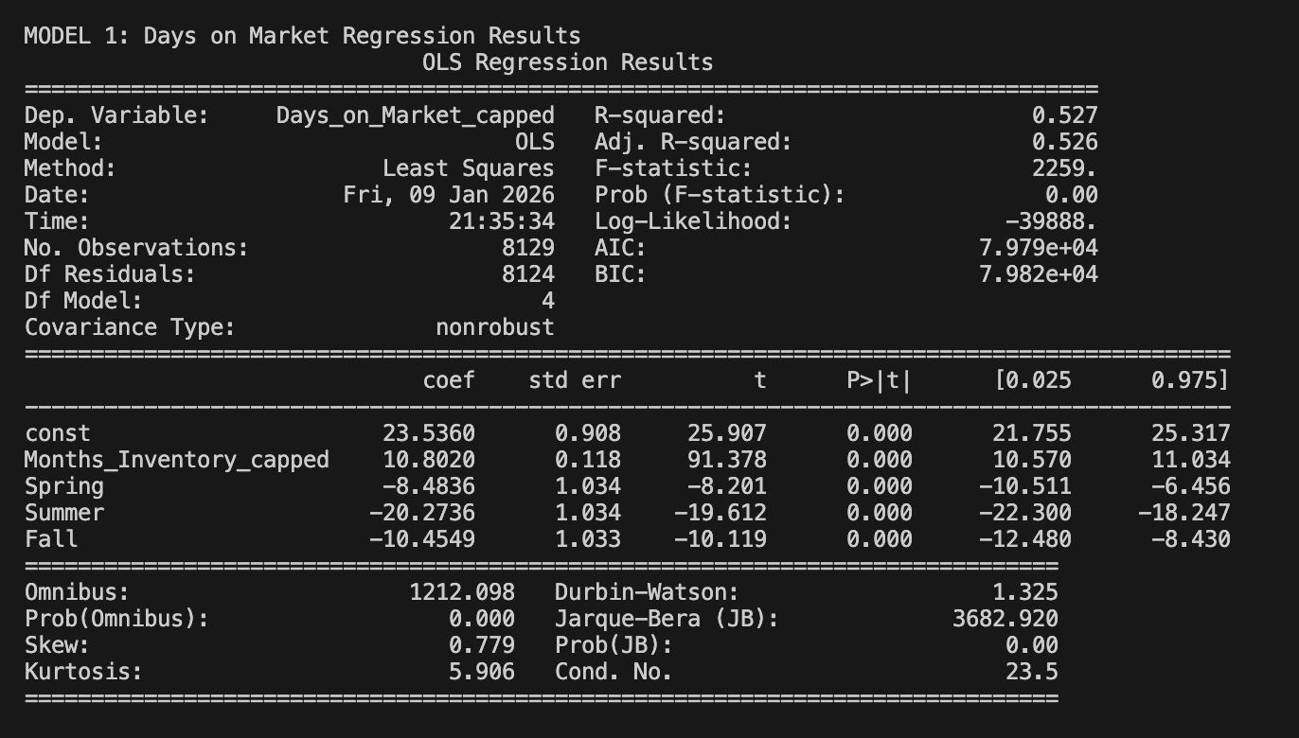

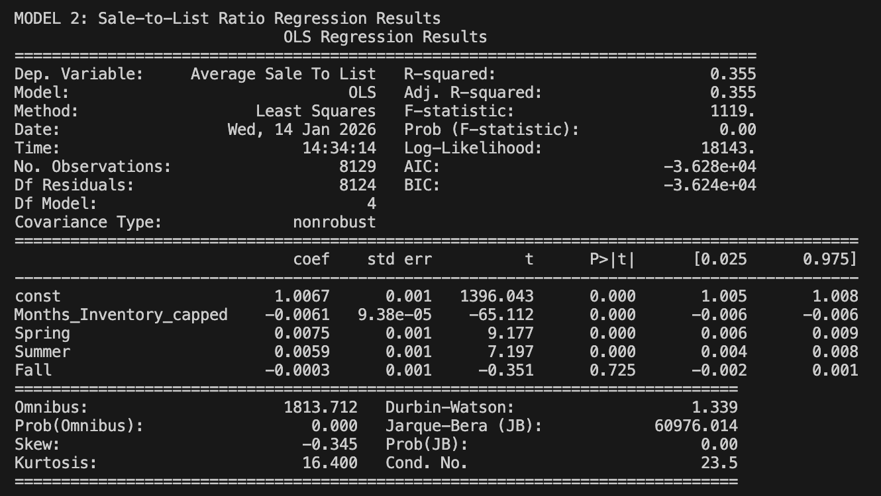

Linear regression models assume normality of the residuals, which represent the deviation of observations from the estimated regression line (Real Python, 2025). The residuals for both the day-on-market and sale-to-list price ratio models are mostly near zero with very symmetric distributions. While there appears to be some skewness and heavier tails, the overall shape does not violate the assumption enough to warrant dismissing the model's validity.

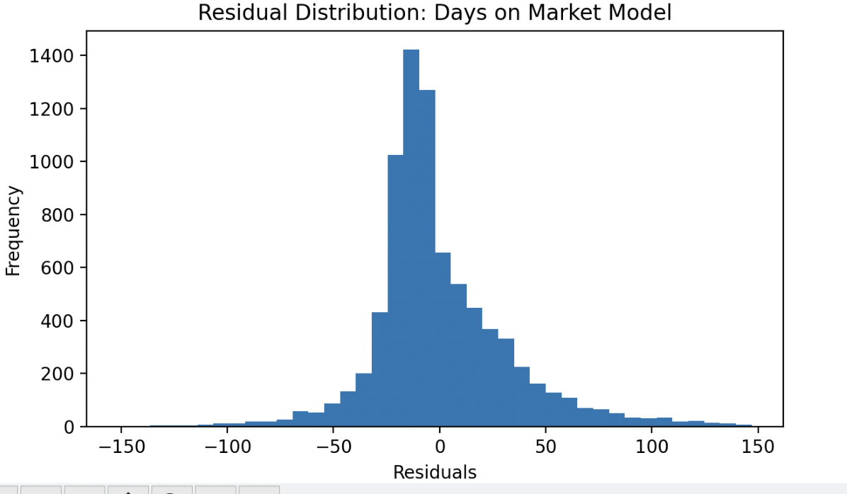

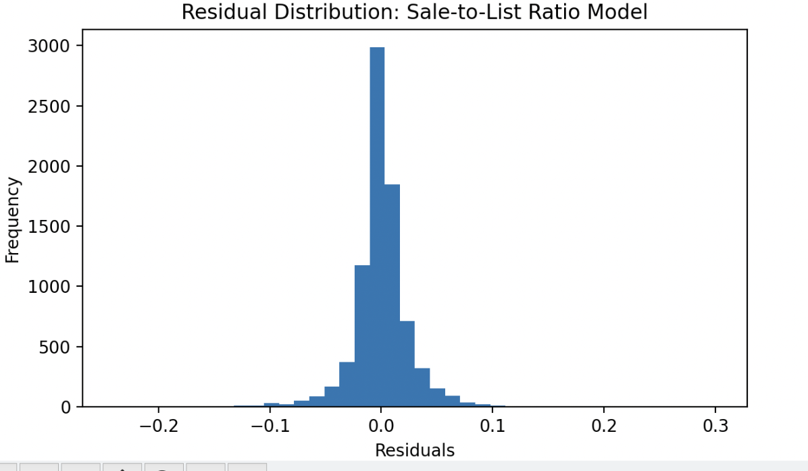
To wrap up the analysis portion of the research, a time-series graph was generated to summarize and reinforce the relationship between the variables. Within the broader temporal framework, this figure illustrates a clear inverse relationship between transaction speed and pricing performance across the duration of observations. Times when days on market are elevated usually align with lower sale-to-list price ratios, while lower days on market suggest the opposite. The other figure demonstrates the observations by month to visualize the relationship between the average days on market for every month and where the average sale-to-list price ratio lines up. Again, as shown in the other figure, there is a clear inverse relationship between the two variables.
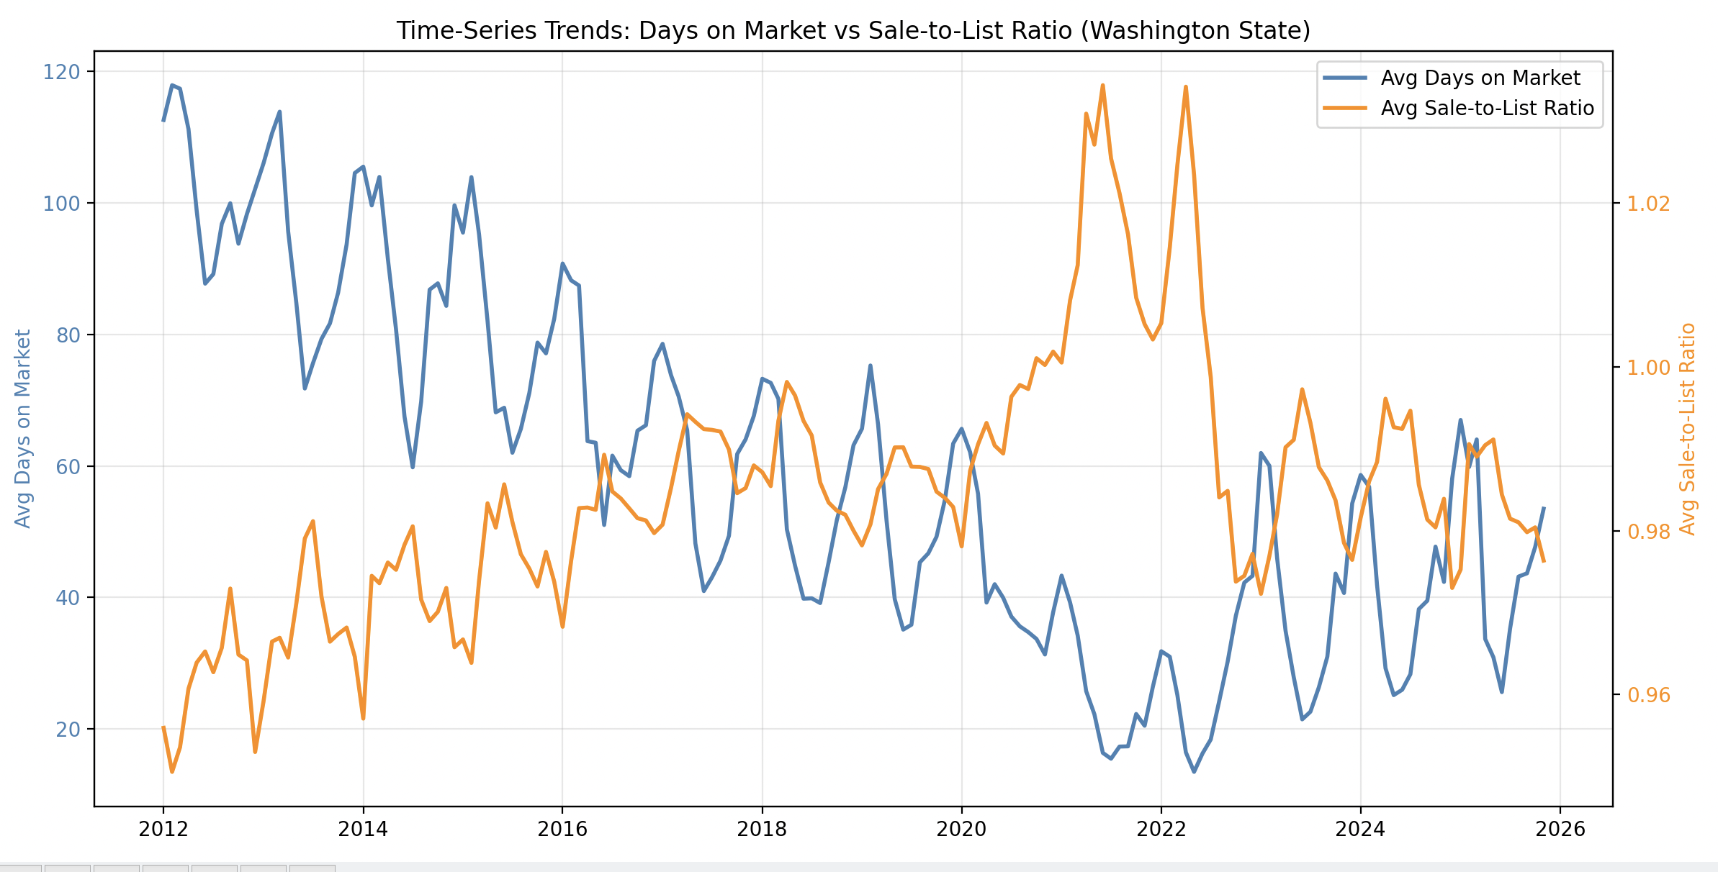

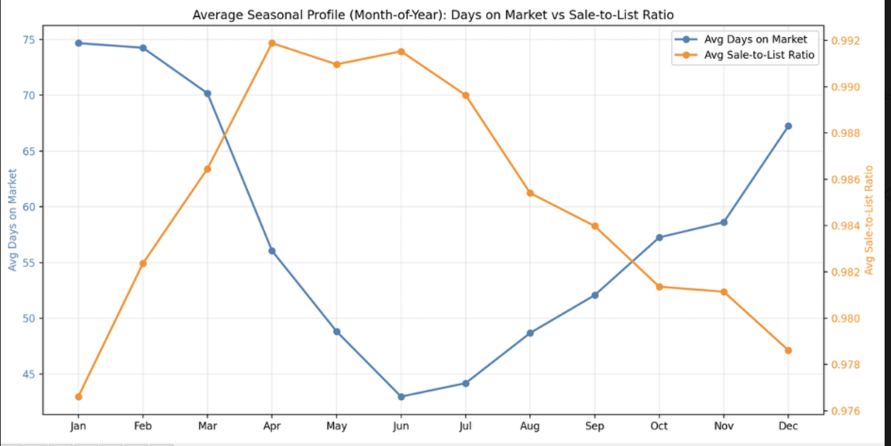
The collective research findings have implications for all real estate market participants, varying by role. The results of this analysis clearly indicate that inventory conditions exert the strongest influence on both speed of sale and pricing outcomes. Despite inventory conditions being a stronger driver, seasonality still remains a statistically significant factor, with summer providing the fastest sales and spring producing the best pricing outcomes. Winter demonstrated both longer days on market and inferior pricing outcomes, supporting the notion that winter yields unfavorable selling conditions for real estate.
As a real estate seller, these findings have significant implications for the decision of when to list a home. For example, controlling for inventory, the difference between a sale in winter and one in spring could be as much as 1%. While this may not seem substantial on the surface, that difference could equate to $10,000 on a $1 million home. If a home seller is in no rush to list their home, patiently waiting a few months might be worthwhile. Not only would the home sell for a higher price relative to winter, but it is also statistically likely to sell faster.
For real estate agents, the implications of the findings suggest that this information should be discussed with their clients, whether they are buyers or sellers. When representing sellers, an agent can discuss listing timing strategy, noting the difference in outcomes by season and inventory conditions. This strategy could involve speeding up or delaying the official listing date, depending on supply dynamics and the seasonal period. Bringing up this data can, at the very least, manage expectations for sellers. By providing the data, an agent sets the precedent for probabilistically likely scenarios. It helps the agent make more accurate claims about a market while ensuring the client is informed.
The practical implications and real-world actions for sellers following this research are two-fold. First, a home listed during the spring or summer can reasonably expect to sell faster at a marginally higher price. Alternatively, homes listed during higher-inventory periods should anticipate more prolonged market exposure and greater pricing concessions. Sellers should use these findings when weighing the net benefits of any listing strategy and strongly consider these factors. Understanding this data can affect the negotiation leverage a seller deploys, ensuring that baseline averages for the overall market are used as proxies for values. Further, risk management can be assessed by evaluating these real estate outcomes.
For agents, there are practical actions that can be taken from the research. To begin, an agent can use this research to pitch to any client and potentially secure them. Converting a lead to a sale often starts with building rapport and trust. Data can be a transparent source of truth. Providing such information to a client can help build that trust quickly, yielding a higher conversion rate. So, if data can help build trust, it can therefore drive sales.
Additionally, home sellers and buyers like to know that an agent has a plan in mind when discussing sales strategy. Agents can leverage the explanatory power of these findings to guide strategy, helping reassure home sellers or buyers that the actions taken are data driven. Agents should use days-on-market and sale-to-list price ratio data during every buyer and seller consultation to inform clients about market conditions, manage expectations, and guide sales strategy to optimize performance.
While this study's findings provide statistically significant insights into the relationship between seasonal and inventory market patterns, several limitations should be acknowledged. First, the analysis relies on aggregated county and metropolitan-level data rather than property-specific observations. These broad market trends ignore a plethora of individual property characteristics that may affect the seasonality and inventory conditions examined, leading to aggregation bias (Bobbit, Z., 2020). Property characteristics such as square footage, lot size, specific neighborhood, and bedroom/bathroom count could further account for the variance. Secondly, the regression model omits potentially useful variables that may exist as external drivers of the outcomes. These variables include macroeconomic shocks, trade wars, interest rates, and property characteristics. While the current model accounts for a large amount of the variance, it does not explain it entirely. Introducing these variables into the model could reduce variance and increase explanatory power.
For future research, the model will compute individual property sales and the characteristics of those homes. Incorporating granular attributes would enable examination of how seasonality and inventory conditions interact with property features. It would provide practical information on the property features, if any, that drive these outcomes. This could be useful to a homeowner looking to remodel but wanting to know the effect an extra bathroom or bedroom might have. Lastly, implementing time-specific interest rates and S&P 500 averages would provide helpful insight into further explaining the list-to-sales price ratio outcomes and seasonal trends.
This study examined whether seasonal market patterns and housing inventory conditions are statistically associated with residential real estate outcomes across Washington State. Using multiple linear regression, the analysis evaluated how the seasonality and months of inventory relate to two key market performance indicators: days on market and sale-to-list price ratio. The multiple linear regression models achieved exemplary explanatory power, exceeding the adjusted R-squared threshold of 0.10 and ultimately supporting the alternative hypothesis. This study demonstrates that seasonality and inventory conditions are significant drivers of real estate outcomes in Washington State, and that the null hypothesis can be rejected.

Sources:

Amplitude. (n.d.). Understanding confidence intervals.
https://amplitude.com/explore/experiment/confidence-intervals

Bobbitt, Z. (2020, September 24). Aggregation bias in statistics. Statology. https://www.statology.org/aggregation-bias/
Crist, M. (2024, April 29). Navigating the housing market: A seasonal perspective. National Association of Realtors. https://www.nar.realtor/blogs/economists-outlook/navigating-the-housing-market-a-seasonal-perspective
CodeSignal. (n.d.). Data validation in Python using pandas. In Data cleaning and validation for machine learning. https://codesignal.com/learn/courses/data-cleaning-and-validation-for-machine-learning/lessons/data-validation-in-python-using-pandas
DataCamp. (n.d.). Linear regression in Python. Retrieved December 29, 2025, from https://www.datacamp.com/tutorial/linear-regression-in-python
DataHen. (2025, April 21). Data Cleaning: Importance, Techniques, and Challenges. DataHen. Retrieved December 27, 2025, from https://www.datahen.com/blog/what-is-data-cleaning-in-data-analysis/
Doerner, W. M., & Lin, W. (2022). Applying seasonal adjustments to housing markets. Cityscape: A Journal of Policy Development and Research, 24(3), 87–? U.S. Department of Housing and Urban Development, Office of Policy Development and Research. https://www.huduser.gov/portal/periodicals/cityscape/vol24num3/ch4.pdf

GeeksforGeeks. (n.d.). ML | Linear Regression. GeeksforGeeks. Retrieved December 26, 2025, from https://www.geeksforgeeks.org/machine-learning/ml-linear-regression/

Jim Frost. (n.d.). How to use confidence intervals to compare means. Statistics By Jim.
https://statisticsbyjim.com/hypothesis-testing/confidence-intervals-compare-means/

Langford, R. (2017, April 7). StatsModels vs. scikit-learn for Linear Regression. Becoming Human: Artificial Intelligence Magazine. Retrieved December 29, 2025, from https://becominghuman.ai/stats-models-vs-sklearn-for-linear-regression-f19df95ad99b
National Center for Ecological Analysis and Synthesis (NCEAS). (2022). Open data and reproducibility. University of California, Santa Barbara.
https://learning.nceas.ucsb.edu/2022-04-arctic/open-data-and-reproducibility.html
Real Python. (2025). Linear regression in Python. Retrieved December 29, 2025, from https://realpython.com/linear-regression-in-python/

Redfin. (n.d.). Redfin Data Center. Redfin. Retrieved December 22, 2025, from https://www.redfin.com/news/data-center/

Shukla, S. (2024). Predicting housing prices using multiple linear regression: A comprehensive analysis. Journal of Emerging Technologies and Innovative Research (JETIR), 11(3). https://www.jetir.org/papers/JETIR2403593.pdf

Valchanov, I. (2023). R-squared: What it is and why it matters for regression analysis. 365 Data Science. https://365datascience.com/tutorials/statistics-tutorials/r-squared/

